INTERNSHIP PROJECT REPORT
Submitted to
INLIGHNX GLOBAL PVT. LTD.
Bangalore, India

Date of Submission
15/01/26

Price Predicting model
Car Price Prediction Model
Model: Linear Regression, Lasso Regression

Prepared by
Nadar Deepthi Chenthil
AI & ML Intern
ITID5802

Internship Duration
15/11/25 – 15/01/26

Index
Sr. no. | Contents | Page no.
1 | Introduction | 3
2 | Problem Statement | 3
3 | Objectives of the Project | 3
4 | Dataset Description | 3
5 | Tools and Technologies Used | 4
6 | System Methodology | 4-6
7 | Model Implementation | 6
8 | Model Training and Testing | 7
9 | Results and Discussion | 7-8
10 | Performance Evaluation | 8-10
11 | Conclusion | 10
12 | Future Scope | 10

Link to GitHub with the .ipynb file containing the implementation code, all dataset .csv files and documentation:

https://github.com/Deepthi-Nadar/Project-using-ml/tree/main

1. Introduction
With the rapid growth of the automobile market, determining the correct resale price of used cars has become a challenging task. The price of a car depends on multiple factors such as brand value, age, fuel type, kilometers driven, and transmission type. Manual estimation often leads to inaccurate pricing.
This project aims to solve this problem using Machine Learning techniques to predict the selling price of used cars based on historical data. The system helps sellers and buyers make informed pricing decisions.

2. Problem Statement
To design and implement a machine learning model that accurately predicts the selling price of a used car using various car-related features. The model should minimize prediction error and provide reliable price estimates.

3. Objectives of the Project
- To analyze the factors affecting car prices
- To preprocess and clean the dataset for better accuracy
- To apply Linear Regression and Lasso Regression models
- To compare predicted prices with actual prices
- To evaluate model performance using suitable metrics

4. Dataset Description
The dataset car data.csv contains information about used cars and their selling prices.

Dataset Features
Feature | Description
Car_Name | Name/model of the car
Year | Year of manufacture
Selling_Price | Price at which the car was sold (Target variable)
Present_Price | Original showroom price
Kms_Driven | Distance driven by the car
Fuel_Type | Type of fuel used
Seller_Type | Dealer or Individual
Transmission | Manual or Automatic
Owner | Number of previous owners

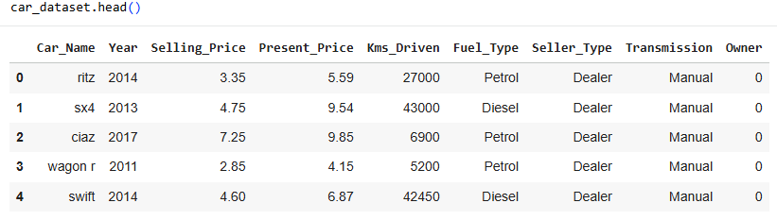

5. Tools and Technologies Used
- Language: Python
- Libraries: Pandas, NumPy, Matplotlib, Seaborn, Scikit-learn
- IDE: Jupyter Notebook
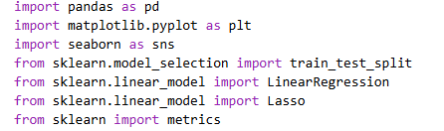

6. System Methodology

6.1 Data Collection
The dataset was collected from a public source containing real-world used car information.

6.2 Data Preprocessing
- Checked for missing and null values
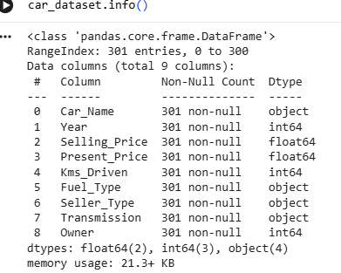

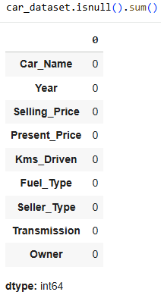
- Converted categorical features into numerical values using Label Encoding
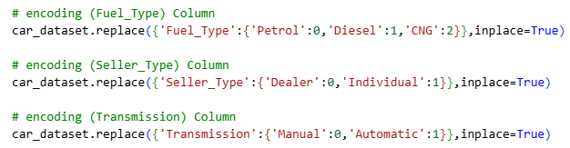
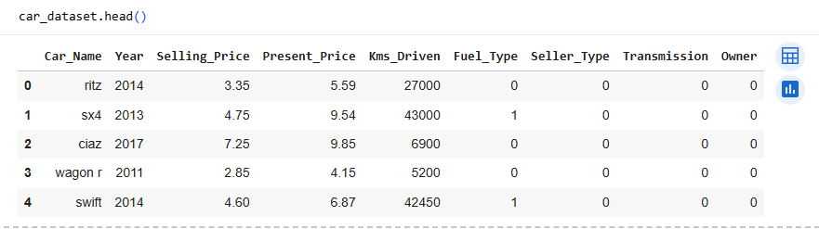
- Selected relevant features for model training
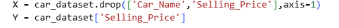

6.3 Feature Engineering
- Extracted meaningful features such as car age from the year
- Transformed categorical data for better model compatibility

7. Model Implementation

7.1 Linear Regression
Linear Regression models the relationship between independent variables and the selling price. It is simple and effective for baseline predictions.
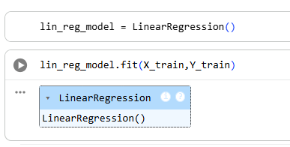

7.2 Lasso Regression
Lasso Regression adds regularization to Linear Regression, helping reduce overfitting and improve prediction stability by penalizing large coefficients.
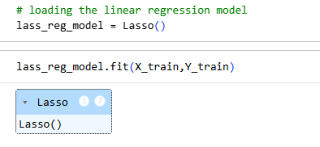

8. Model Training and Testing
- The dataset was split into training (90%) and testing (10%) sets
- Models were trained using the training dataset
- Predictions were made on the testing dataset
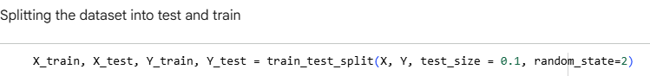

9. Performance Evaluation
The models were evaluated using:
- Mean Absolute Error (MAE)
- Mean Squared Error (MSE)
- R² Score
1. Linear Regression
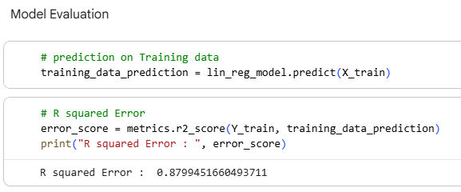
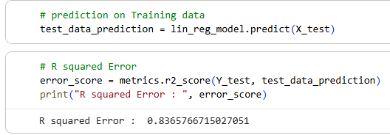

2. Lasso Regression
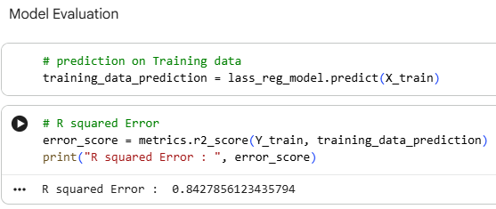
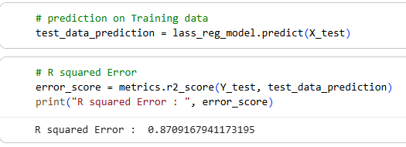
These metrics help measure prediction accuracy and error rate.

10. Results and Discussion
- Linear Regression provided acceptable prediction results
- Lasso Regression reduced overfitting and improved model generalization
- Predicted prices were close to actual prices for most samples

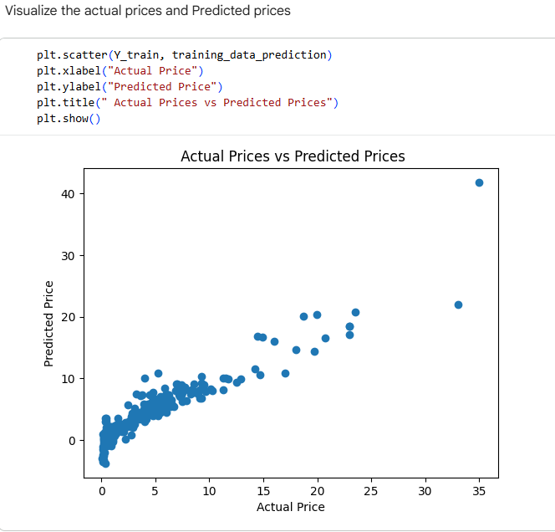

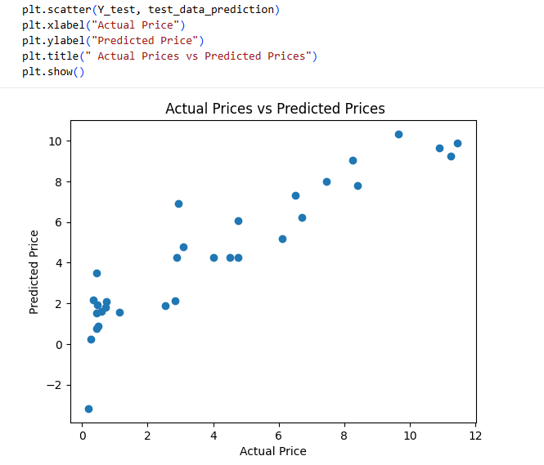

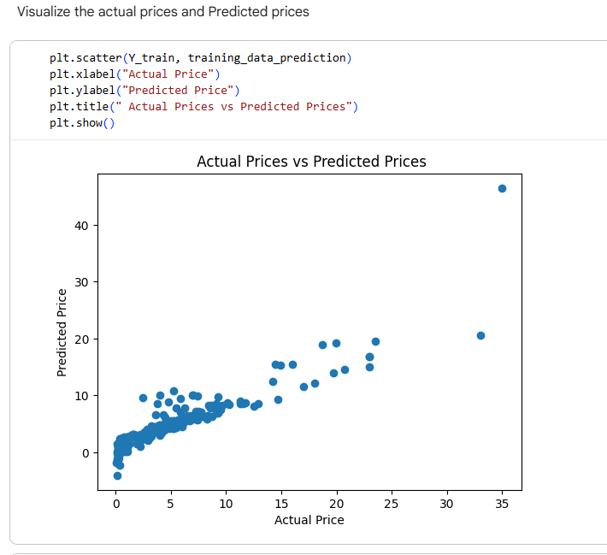

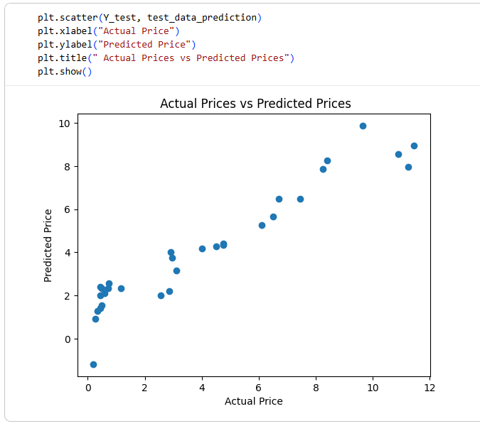
Graphical comparisons between actual vs predicted prices show the effectiveness of the models.

11. Conclusion
This project demonstrates that machine learning can effectively predict used car prices using regression techniques. Both Linear and Lasso Regression models performed well, with Lasso offering better control over overfitting. The system can be useful for real-world car resale platforms.

12. Future Scope
- Apply advanced algorithms like Random Forest or XGBoost
- Increase dataset size for better accuracy
- Deploy the model as a web application
- Add more features like car condition and service history

